DAY 1

CLASS EXERCISES

1. GET - "/welcome"

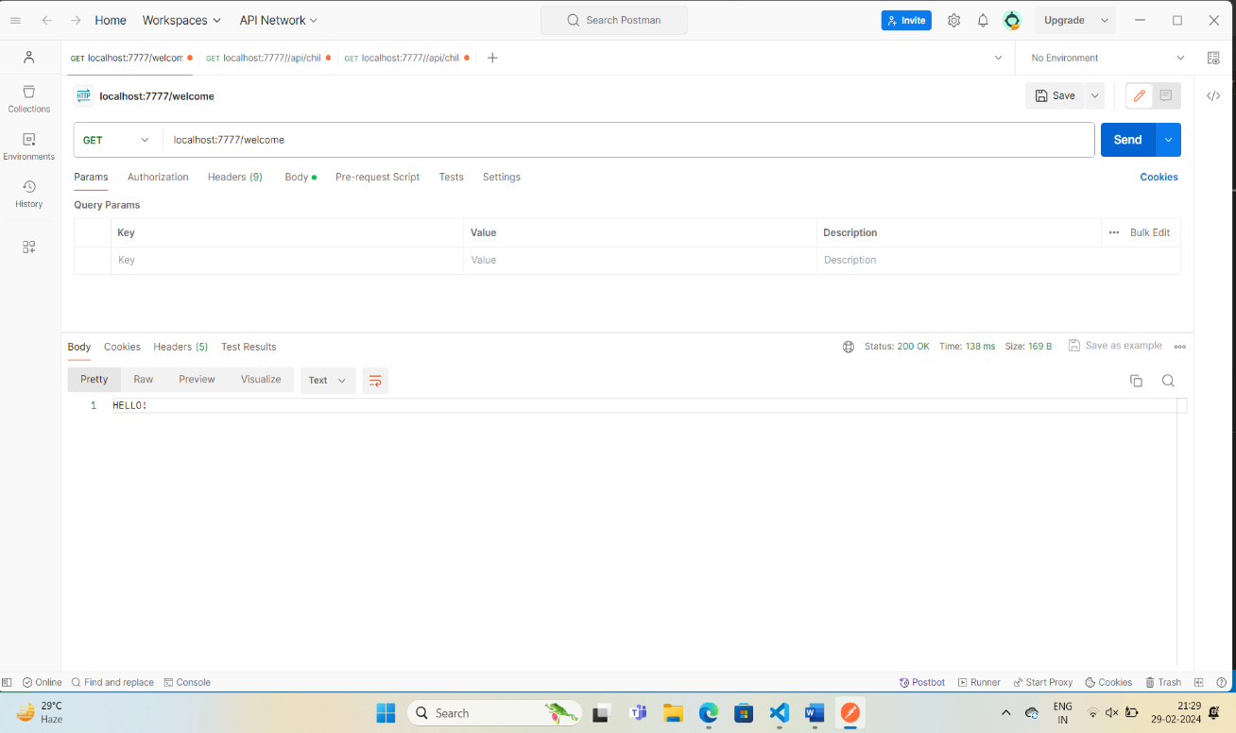

1. GET - "/studentName"

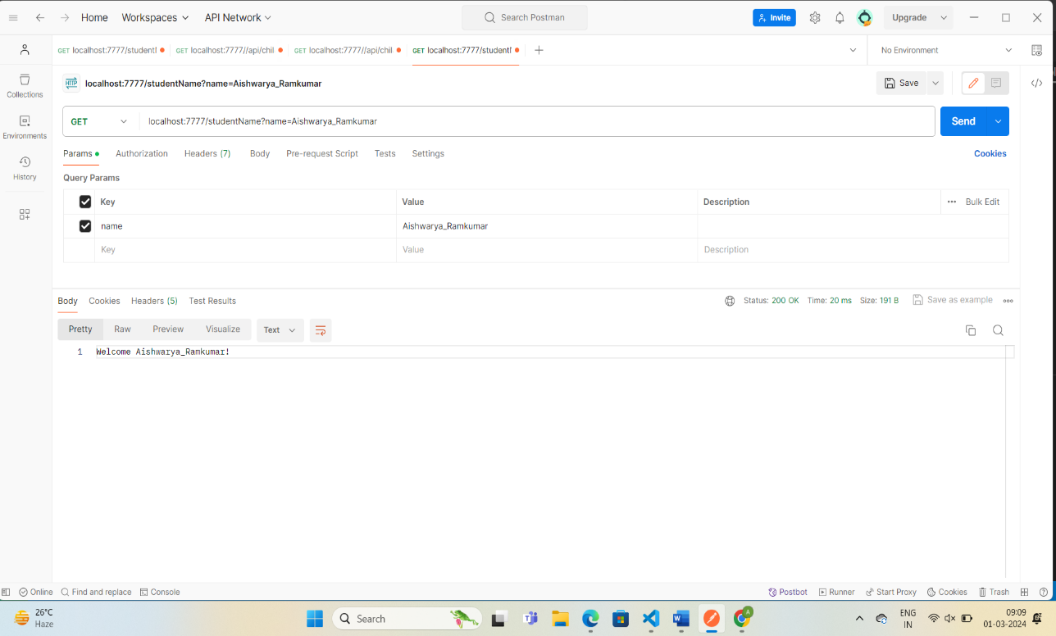

1. GET - "/favouriteColor"

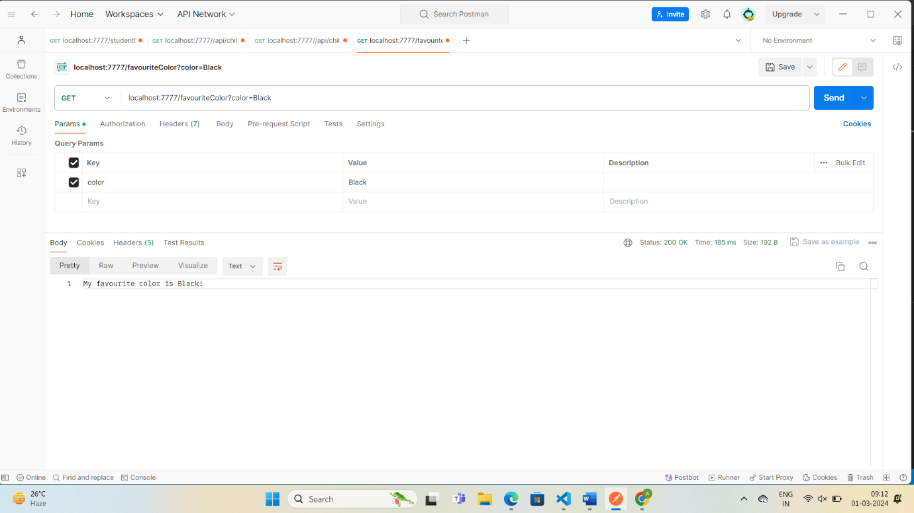

1. GET - "/address" - retrieves the address object.

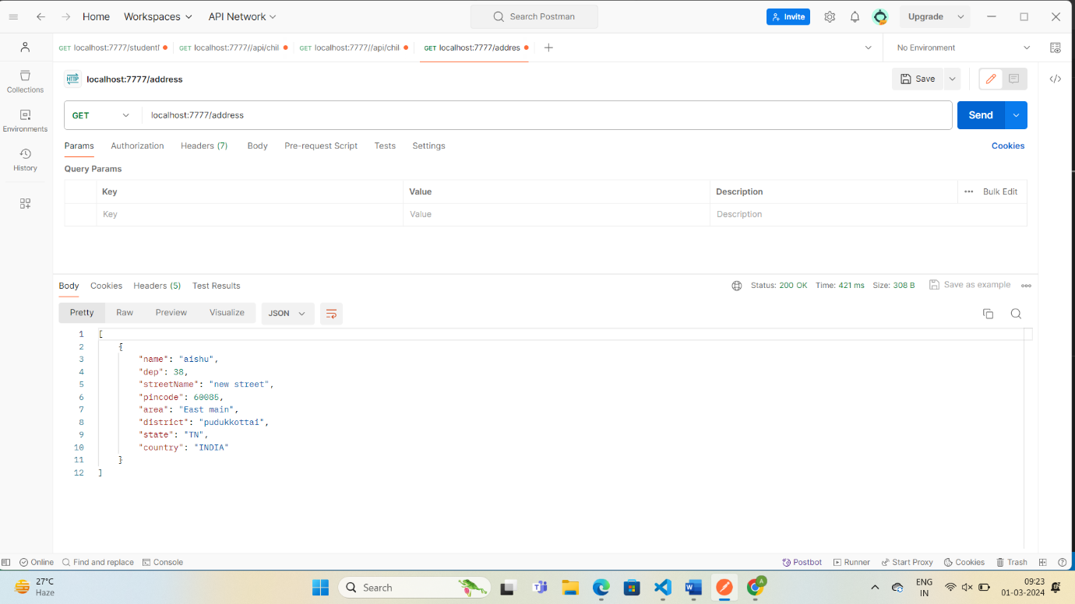

5) GET - "/student" - Retrieves List<Student> object.

